2023-2025 OPHTC Conference and Continued Education Fund – Call for Applications (Sep. 5, 2023)

The Oklahoma Public Health Training Center (OPHTC) is pleased to announce a new mechanism to support Community Health Workers (CHWs) in Oklahoma. Thanks to a generous, anonymous gift made to The University of Oklahoma Foundation, Inc., the OPHTC CHW program within the Hudson College of Public Health will support CHWs through scholarships to provide continuing education for conferences and other educational opportunities. Scholarship amounts are fixed at $500 per recipient for in-state, and $1,500 per recipient for national conferences and other educational opportunities. Stipends will be provided upon completion of the educational opportunity and submission of deliverables. Applications can be submitted on a rolling basis. The number of scholarships to be awarded over two years depends on the type of successful applications (in-state or national).
Applicant Eligibility Criteria:
- Applicant must be a practicing CHW (including a CHW in supervisory position) as defined by
  - APHA https://www.apha.org/apha-communities/member-sections/community-health-workers
  - C3 Project https://www.c3project.org/
  - OPHA CHW Section CHW membership titles https://oklahomapublichealthassn.wildapricot.org/page-643525
Application Procedures
- Interested CHWs should complete the application form available at https://forms.gle/Vet2CPwpB1joVqFa6
- The applicant’s CHW program administrator/director/supervisor should submit a brief statement of support to OPHTC@OUHSC.edu. The statement should include:
  - Confirmation of applicant’s CHW role and title
  - Clearly stated approval of applicant’s participation in the scholarship process and reception of funds
Successful applicants will be notified through an official letter of award.
Within 2 weeks of completing the conference or other educational opportunities, scholarship awardees should submit the following to OPHTC@OUHSC.edu:
- Proof of registration for the conference or other educational opportunity
- Brief report (in writing with up to 150 words, or as a 1–3 minutes video recording) on experiences at the conference or other educational opportunity, including overall impressions and key lesson(s) learned.
  - Note: This report may be shared publicly, such as on the OPHTC webpage https://ophtc.ouhsc.edu/Training
Upon submission of deliverables, CHW scholarship awardees will receive the following:
- Scholarship amount as given in the award letter
- Certificate of scholarship received
- Certificate of attendance/presentation for conference or other educational opportunity
Contact information:
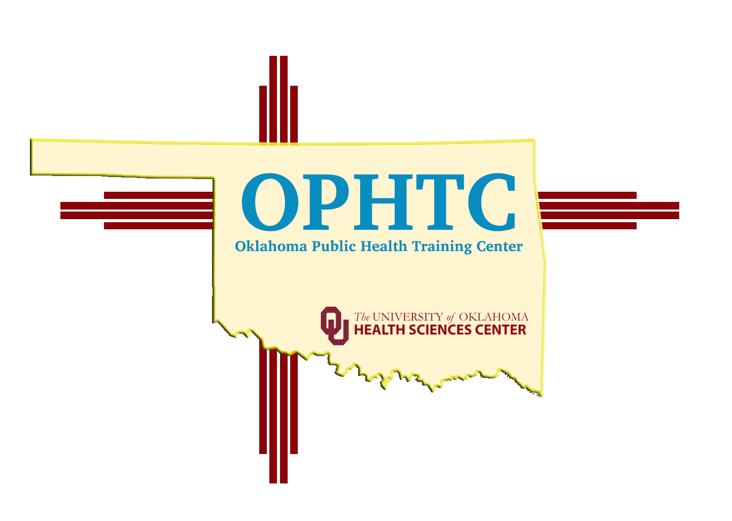
- OPHTC@OUHSC.edu

